Cells – How do they carry out the activities of life?

What are cells? A cell is the smallest living thing. This means that a cell is the smallest thing that can carry out the activities of life. For example, a cell can:
- respond to the world around it
- use energy
- grow
- make new cells (reproduce)
- keep things steady inside (maintain homeostasis).

1. Watch the video of an animal cell chasing and then eating bacteria (https://www.youtube.com/watch?v=Z_mXDvZQ6dU). What are two activities of life that are shown by this animal cell?

Every cell has these parts.  - Cell membrane: The cell membrane surrounds the cell and controls what gets into and out of the cell.  - DNA: DNA is the genetic material, which gives the instructions for making proteins. | 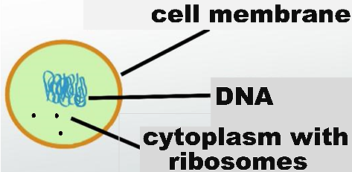
- Ribosomes: Ribosomes are the molecular machines that make proteins.
- Cytoplasm: The cytoplasm includes the ribosomes.
Proteins make crucial contributions to the activities of life. For example, molecular changes in proteins caused the movement of the animal cell as it chased the bacteria. Also, some proteins are:  - enzymes (e.g., enzymes that help the cell to use energy, grow or reproduce)  - pores or pumps in the cell membrane, which | 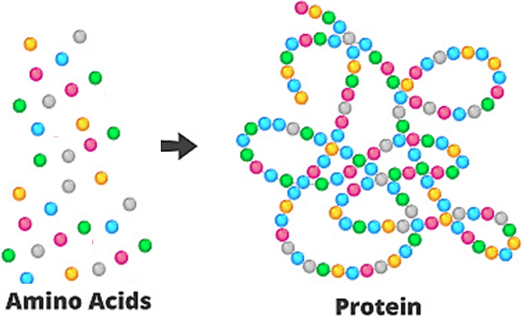
help the cell membrane to maintain homeostasis (keep things steady inside).

2. Describe how the cell parts listed in this table contribute to the activities of life.

Cell Parts | How These Cell Parts Contribute to the Activities of Life
DNA and ribosomes
Cell membrane

3a. Are molecules like DNA and proteins alive? yes ___ no ___

3b. How do you know?

Different Types of Cells
Animal cells and bacterial cells are examples of two fundamentally different types of cells – eukaryotic cells and prokaryotic cells (see table and figure below).

In a eukaryotic cell, the DNA is surrounded by a nuclear membrane. | In a prokaryotic cell, the DNA is not surrounded by a membrane.
An animal or plant has multiple eukaryotic cells. (There are additional types of organisms that have multiple eukaryotic cells or a single eukaryotic cell.) | A prokaryote is an organism that consists of a prokaryotic cell. Bacteria are one type of prokaryote.

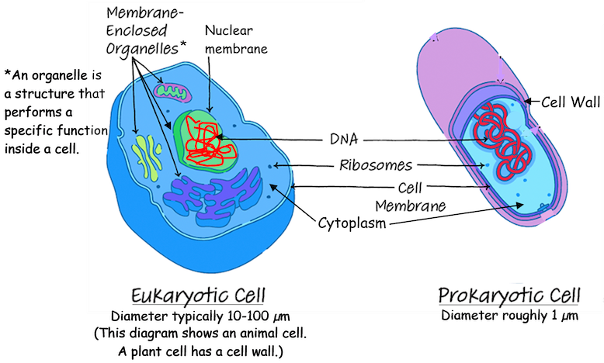

4a. The diameter of a eukaryotic cell is about ____ - ______ times bigger than the diameter of a prokaryotic cell. (Hint: Use the information near the bottom of the figure.)

4b. Draw the outline of a prokaryotic cell that is about 1/10 as wide as the diagram of the eukaryotic cell. This will give a better picture of how much smaller a prokaryotic cell really is.

4c. Eukaryotic cells are bigger than prokaryotic cells, but they are still tiny. View the animation at https://learn.genetics.utah.edu/content/cells/scale/. Which is the biggest?
a grain of salt ___ a red blood cell ___ a skin cell ___

4d. Your skin cells are _____________________ cells.
(eukaryotic / prokaryotic)

5. Eukaryotic and prokaryotic cells are very different in size and internal structure. Why do both of these types of cells need DNA, ribosomes and a cell membrane?

To review and learn more, watch the video, “Prokaryotic vs. Eukaryotic Cells” (https://www.youtube.com/watch?v=Pxujitlv8wc).

Organelles in Animal Cells.
An organelle is a structure that performs a specialized function inside a cell. For example, ribosomes make proteins. Eukaryotic cells have several additional types of organelles. These organelles are surrounded by membranes.
- The nucleus contains the DNA which gives the instructions for making proteins.
- In a eukaryotic cell, some of the ribosomes are attached to the membranes of the rough endoplasmic reticulum. These ribosomes produce proteins that will be secreted from the cell (e.g., protein hormones) or will become part of the cell membrane (e.g., protein pumps). These proteins are prepared for secretion or insertion in the cell membrane by processing in the rough endoplasmic reticulum and the Golgi apparatus.
- Mitochondria make ATP, which provides the energy needed for many cellular processes.
- In animal cells, lysosomes contain enzymes that digest worn out cellular materials. These enzymes also digest any bacteria eaten by a cell.

6a. The diagram below shows an animal cell. Several of the organelles work together to make and process proteins that will be secreted from the cell. Next to the name of each of these organelles, briefly describe its function.

6b. Circle the name of the organelle that makes the ATP that provides the energy for protein production and secretion.

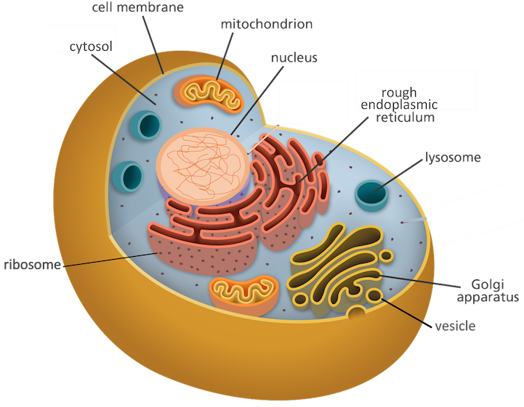
7. The different parts of a eukaryotic cell work together to accomplish the cell’s functions. Some eukaryotic cells can be thought of as factories that make protein hormones and secrete them. Which parts of the cell accomplish each of the functions listed in the table below?

Factory (Cell) Function | What part or parts of the cell  accomplish this function?
Management – sends out instructions (DNA –>
RNA) for making each product (protein)

Workbench – uses instructions to make products (RNA – > proteins)

Processing – prepares products (proteins) to
leave factory (cell)

Security Fence with Gates – controls what
comes into or leaves the factory (cell)

Powerhouse – provides energy in a form the
factory (cell) can use (ATP)

Cleanup crew – disposes of worn out
equipment and products

One advantage of being multicellular is that different cells can specialize for different activities of life. The animal cell in the first video was a phagocyte. A phagocyte is a type of white blood cell that defends our bodies against infection by killing bacteria.

Phagocytes move out of the blood in the capillaries (the smallest blood vessels). Phagocytes squeeze between the cells of the capillary wall and move toward an infected injury. Then, phagocytes engulf the bacteria. The chemicals and enzymes in the phagocytes’ lysosomes kill and digest the bacteria.
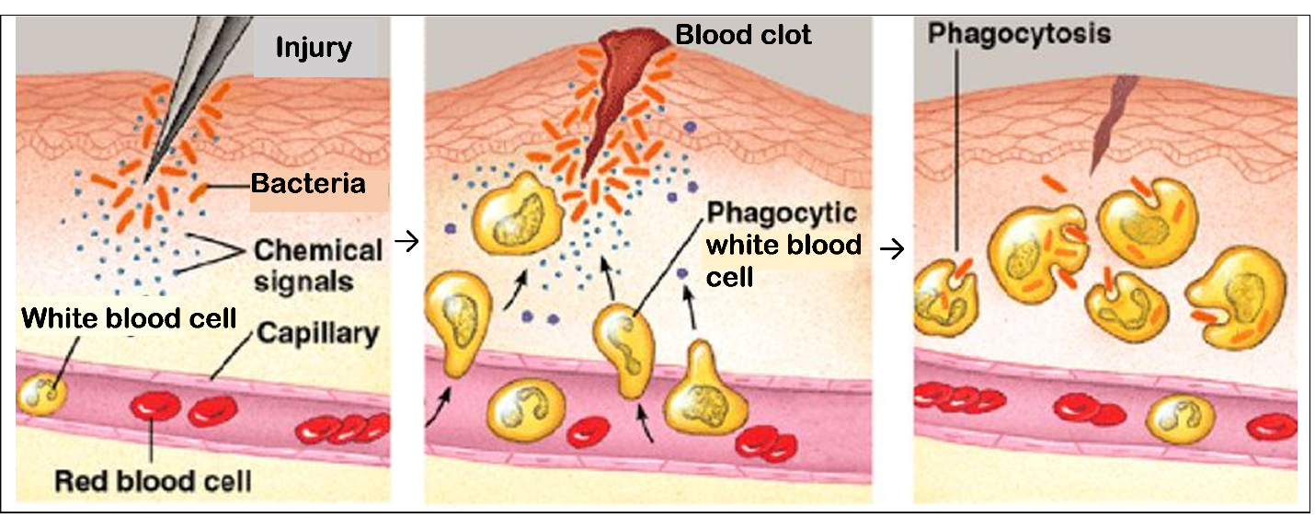
8. Each phagocyte has more lysosomes than a typical animal cell. Explain how these lysosomes help a phagocyte to accomplish its function.

Plant Cells. Many parts of plant cells are also found in animal cells. However, plant cells have several additional cell parts. Plant cells have:
- Chloroplasts: Chloroplasts use light energy, CO₂ and H₂O to make sugars.
- Cell wall and central vacuole: Cell walls and central vacuoles work together to provide structural support for the plant.
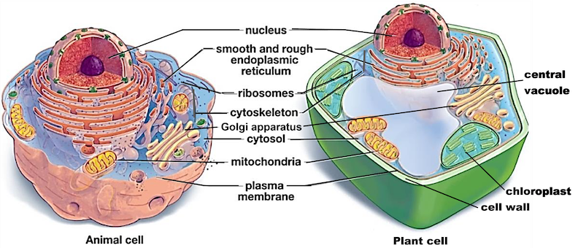

9. In the diagram of the plant cell, draw an arrow from the organelle that makes sugars to the organelle that uses sugars in a process that makes ATP.

10. Explain why the structures listed in the table are useful for plant cells, but not needed or even a disadvantage for animal cells.

 | Why These Parts  are Useful in Plant Cells | Why These Parts Are Not Needed in Animal Cells or Even a Disadvantage for Animal Cells
Chloroplasts
Cell wall and central vacuole

11. Fill out this Venn diagram; in appropriate areas, list cell parts that are found only in eukaryotic cells or found in both eukaryotic and prokaryotic cells. Put an asterisk (*) next to cell parts that are found in plant cells, but not in animal cells.
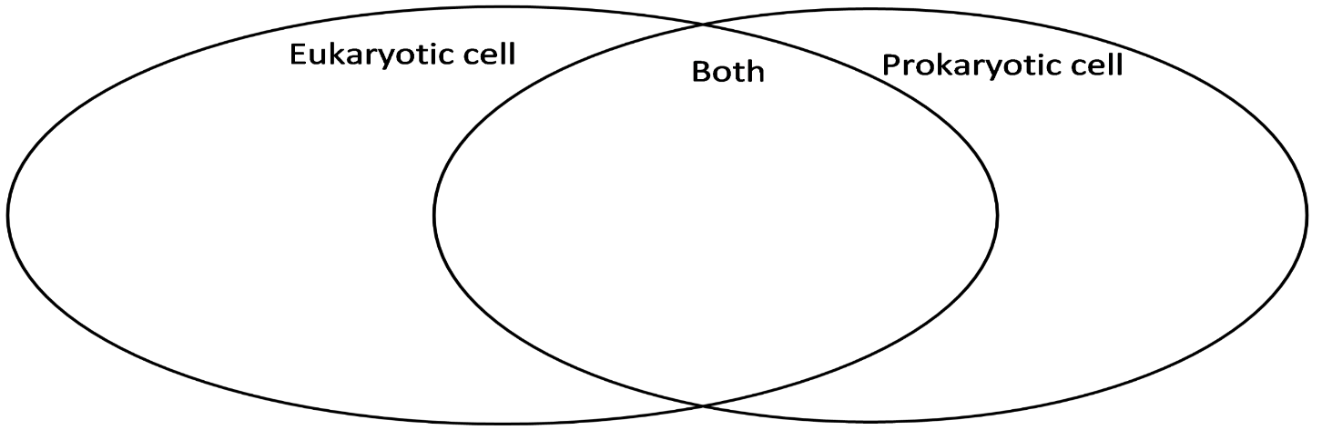

By Dr. Ingrid Waldron, Dept Biology, Univ Pennsylvania, © 2025. This simpler Student Handout, a more complete Student Handout, and Teacher Notes with instructional suggestions and background biology are available at https://serendipstudio.org/exchange/bioactivities/Cells.

